CSA1708 – AI PROLOG LAB EXPERIMENTS
Rhema Daphne EG (129321097)

Experiment 17: Sum of Integers from 1 to N
Aim:
To write and execute a Prolog program to calculate the sum of integers from 1 to N.
Algorithm:
- Start the program.
- Define the base case: the sum of 0 is 0.
- If N is greater than 0, subtract 1 from N.
- Recursively calculate the sum of the previous integers.
- Add N to the previous sum.
- Display the final sum.
- Stop the program.

Program:

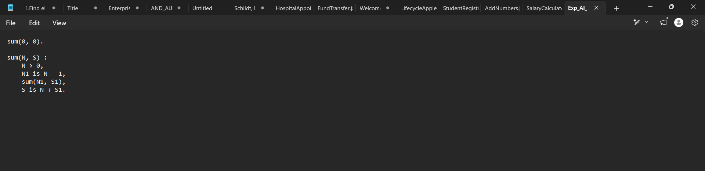

Output:

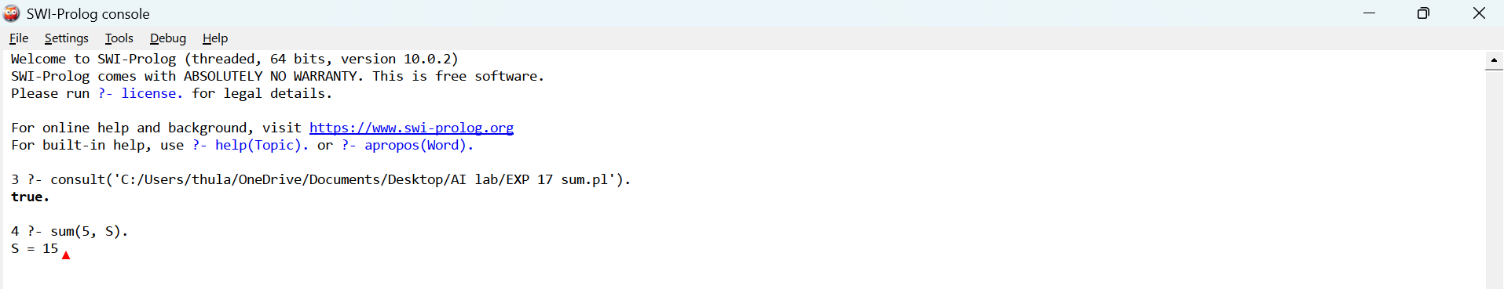
Result:
Thus, the Prolog program to calculate the sum of integers from 1 to N was successfully executed, and the output was obtained.

Experiment 18: Prolog Program for a Database with Name and DOB
Aim:
To write and execute a Prolog program to create a database containing names and dates of birth (DOB) and retrieve the details using queries.
Algorithm:
- Start the program.
- Define facts containing each person's name and date of birth.
- Load the program into SWI-Prolog.
- Execute a query to retrieve the name and DOB.
- Display the results.
- Stop the program.
Program:


Output
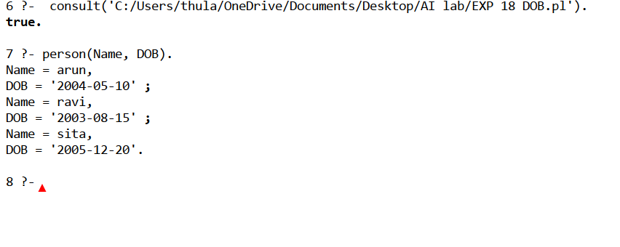

Result:
Thus, the Prolog program to create a database containing names and dates of birth and retrieve the details was successfully executed.

Experiment 19: Student–Teacher–Subject Code
Aim:
To write and execute a Prolog program to store and retrieve student names, teacher names, and subject codes.
Algorithm:
- Start the program.
- Define facts containing student names, teacher names, and subject codes.
- Load the program into SWI-Prolog.
- Execute a query to retrieve the details.
- Display the results.
- Stop the program.
Program:


Output:

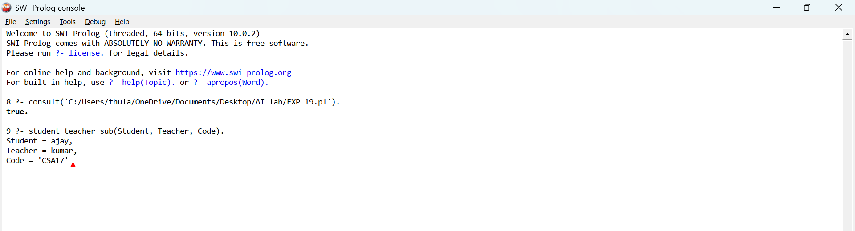

Result:
Thus, the Prolog program to store and retrieve student, teacher, and subject code details was successfully executed.

Experiment 20: Prolog Program for Planets Database
Aim:
To write and execute a Prolog program to create a database of planets and retrieve their details.
Algorithm:
- Start the program.
- Define facts containing the names of planets.
- Load the program into SWI-Prolog.
- Execute a query to retrieve the planet names.
- Display the output.
- Stop the program.
Program


Output
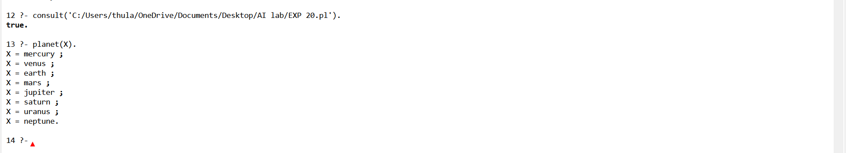

Result
Thus, the Prolog program to create a planets database and retrieve the planet names was successfully executed.

Experiment 21: Towers of Hanoi
Aim:
To write and execute a Prolog program to solve the Towers of Hanoi problem.
Algorithm:
- If there is one disk, move it directly from source to destination.
- Move N−1N-1N−1 disks from source to auxiliary.
- Move the largest disk from source to destination.
- Move N−1N-1N−1 disks from auxiliary to destination.
Program
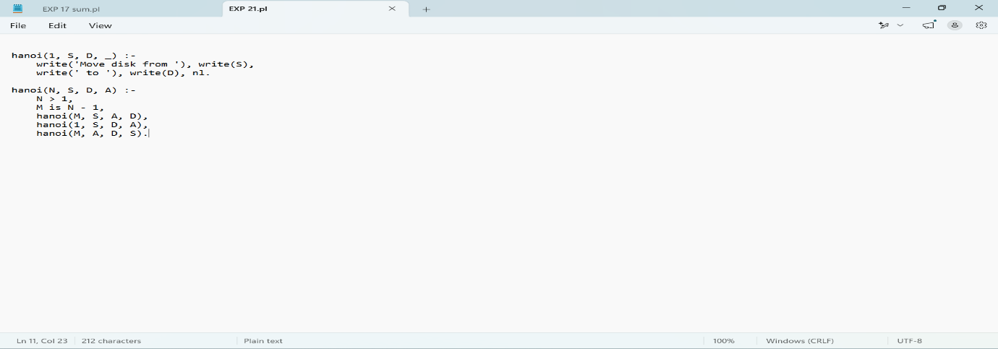

Output
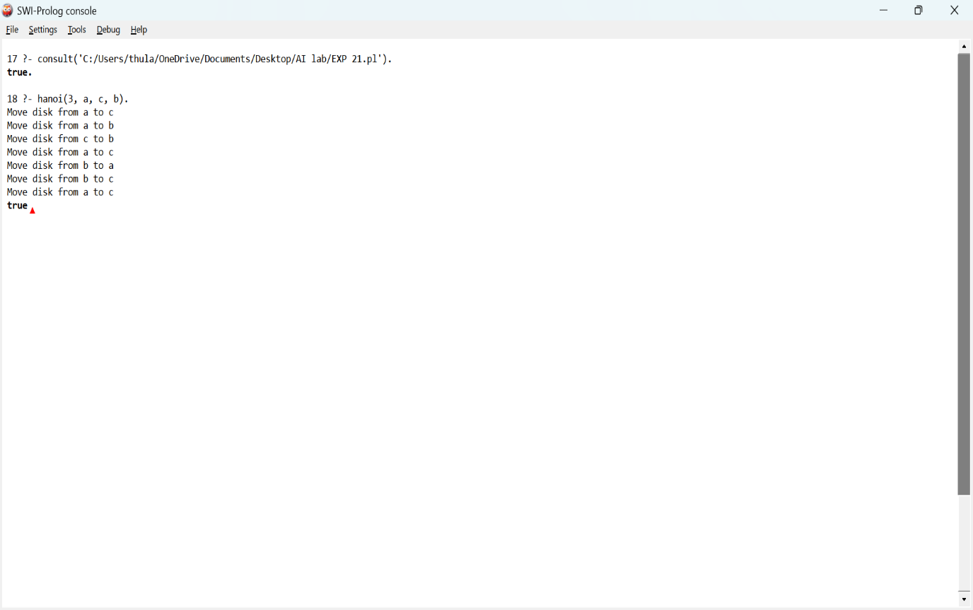

Result
Thus, the Towers of Hanoi program was successfully executed.
Experiment 22: Check Whether a Bird Can Fly
Aim:
To write and execute a Prolog program to determine whether a particular bird can fly.
Algorithm:
- Define birds that can fly.
- Define birds that cannot fly.
- Query whether a particular bird can fly.
- Display the result.

Program
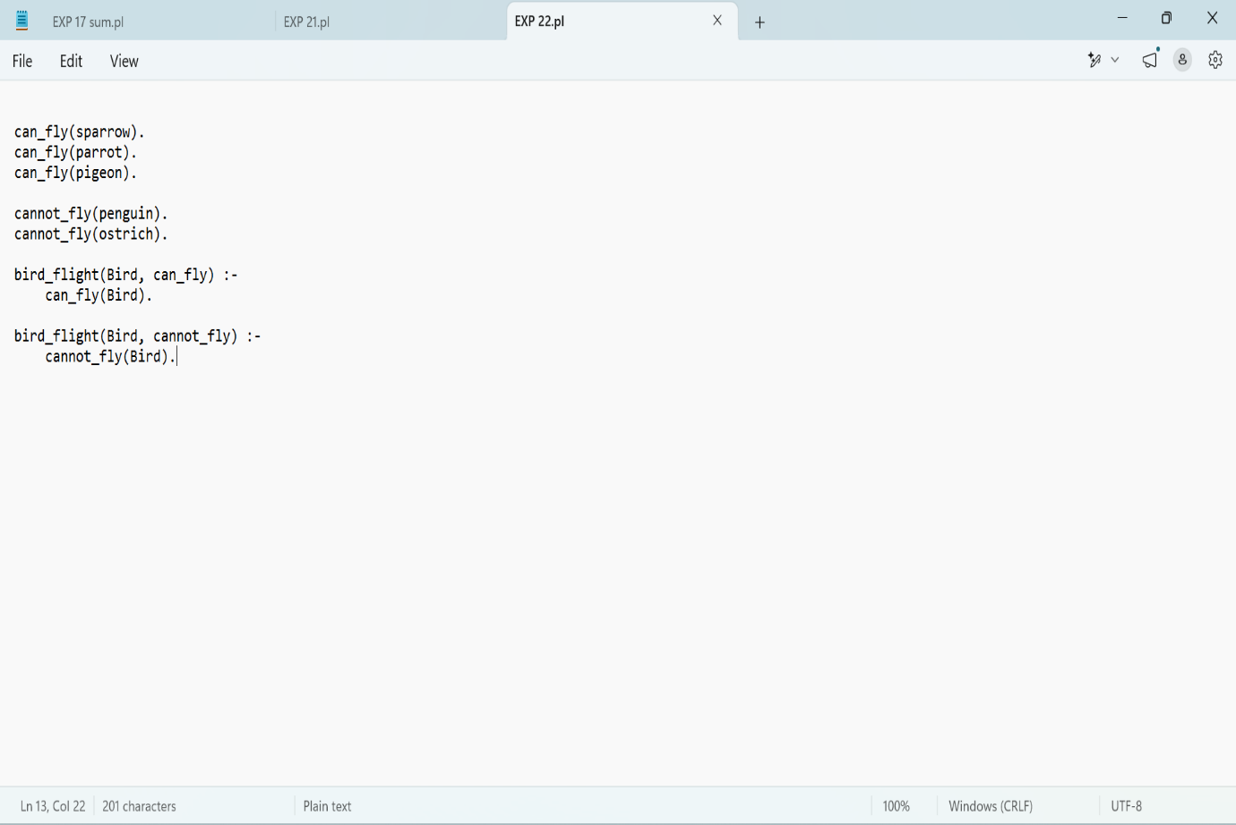

Output

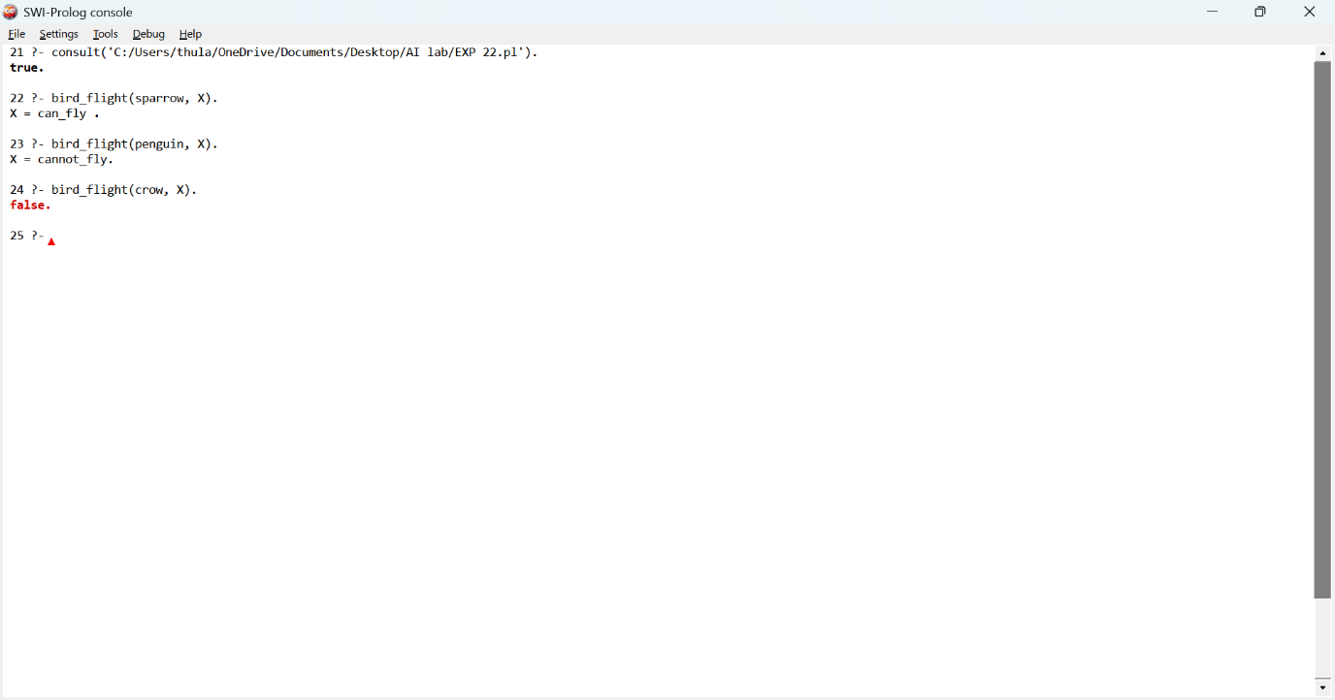

Result:
Thus, the program to check whether a bird can fly was successfully executed.
Experiment 23: Prolog Program to Implement Family Tree

Aim:
To write and execute a Prolog program to implement a family tree using facts and rules to identify family relationships.
Algorithm:
- Start the program.
- Define parent relationships using Prolog facts.
- Define rules to identify grandparent and father relationships.
- Load the program into SWI-Prolog.
- Execute queries to check family relationships.
- Display the results.
- Stop the program.
CODE:
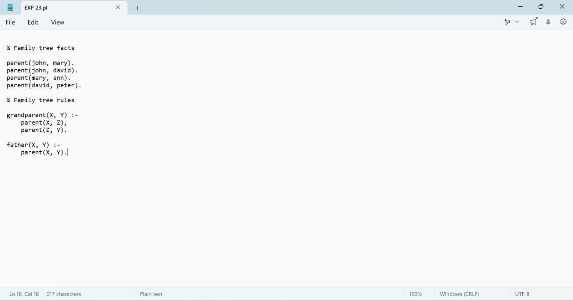

OUTPUT
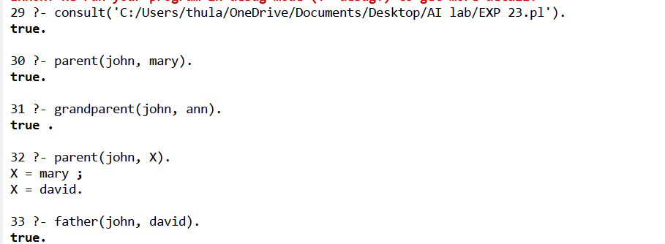

Result:
Thus, the family tree was successfully represented using Prolog facts and rules. The parent, grandparent, and father relationships were queried and verified successfully.

Experiment 24: Prolog Program to Suggest Dieting System Based on Disease
Aim
To write and execute a Prolog program to suggest suitable dietary recommendations based on a person's disease.
Algorithm
- Start the program.
- Define dietary suggestions for different diseases.
- Create rules to identify the disease.
- Accept the disease as a query.
- Retrieve the corresponding diet suggestion.
- Display the recommended diet.
- Stop the program.
Code
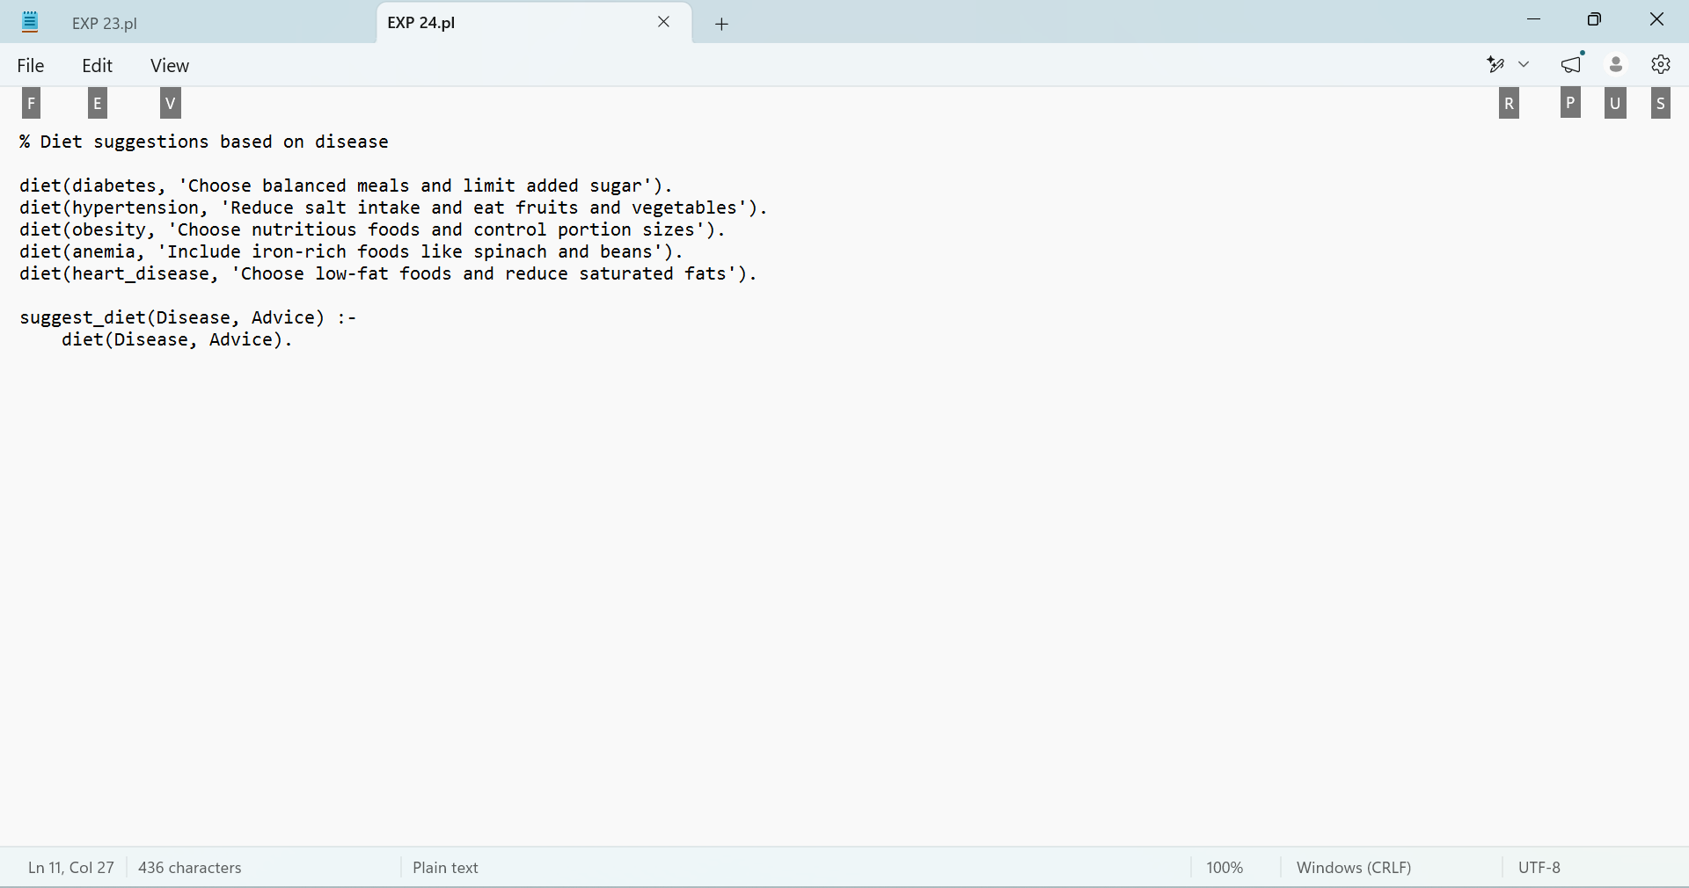

Output
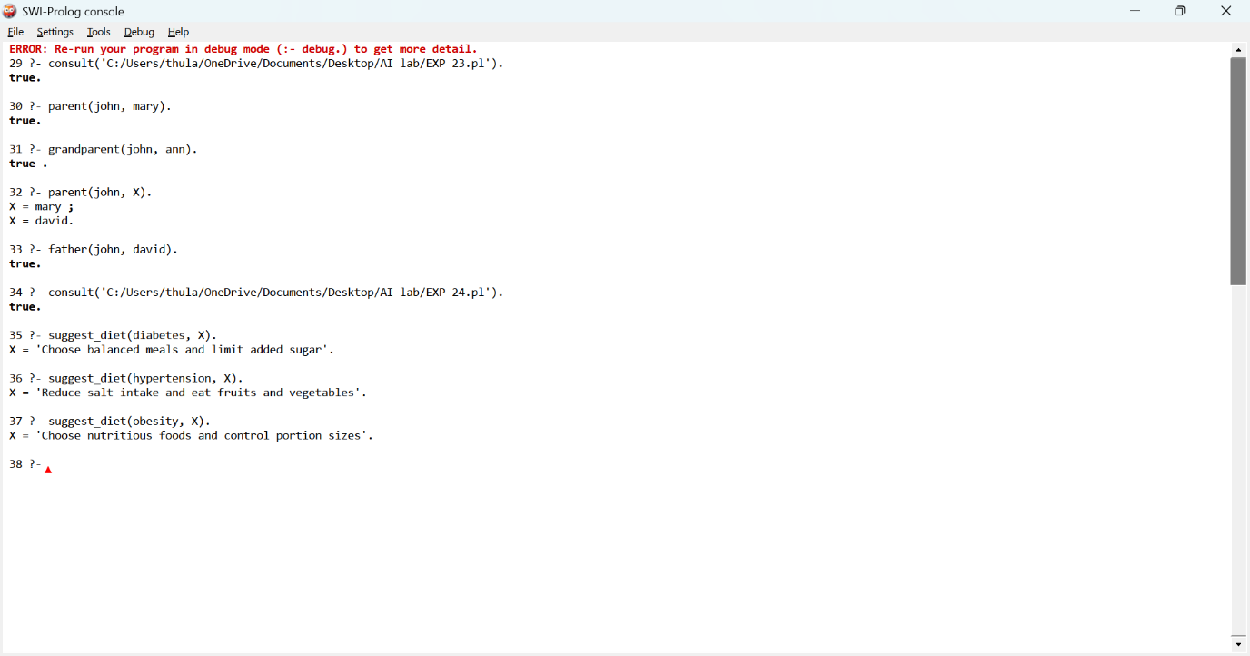

Result
Thus, the Prolog program to suggest dietary recommendations based on different diseases was successfully executed.
Experiment 25: Prolog Program to Implement Monkey Banana Problem
Aim
To write and execute a Prolog program to implement the Monkey Banana Problem using logical rules and facts to determine how a monkey can reach and get bananas.
Algorithm
- Start the program.
- Define the initial position of the monkey, box, and bananas.
- Check whether the monkey can move the box.
- Move the box below the bananas.
- Allow the monkey to climb onto the box.
- Check whether the monkey can reach the bananas.
- Display the result.
- Stop the program.
Code
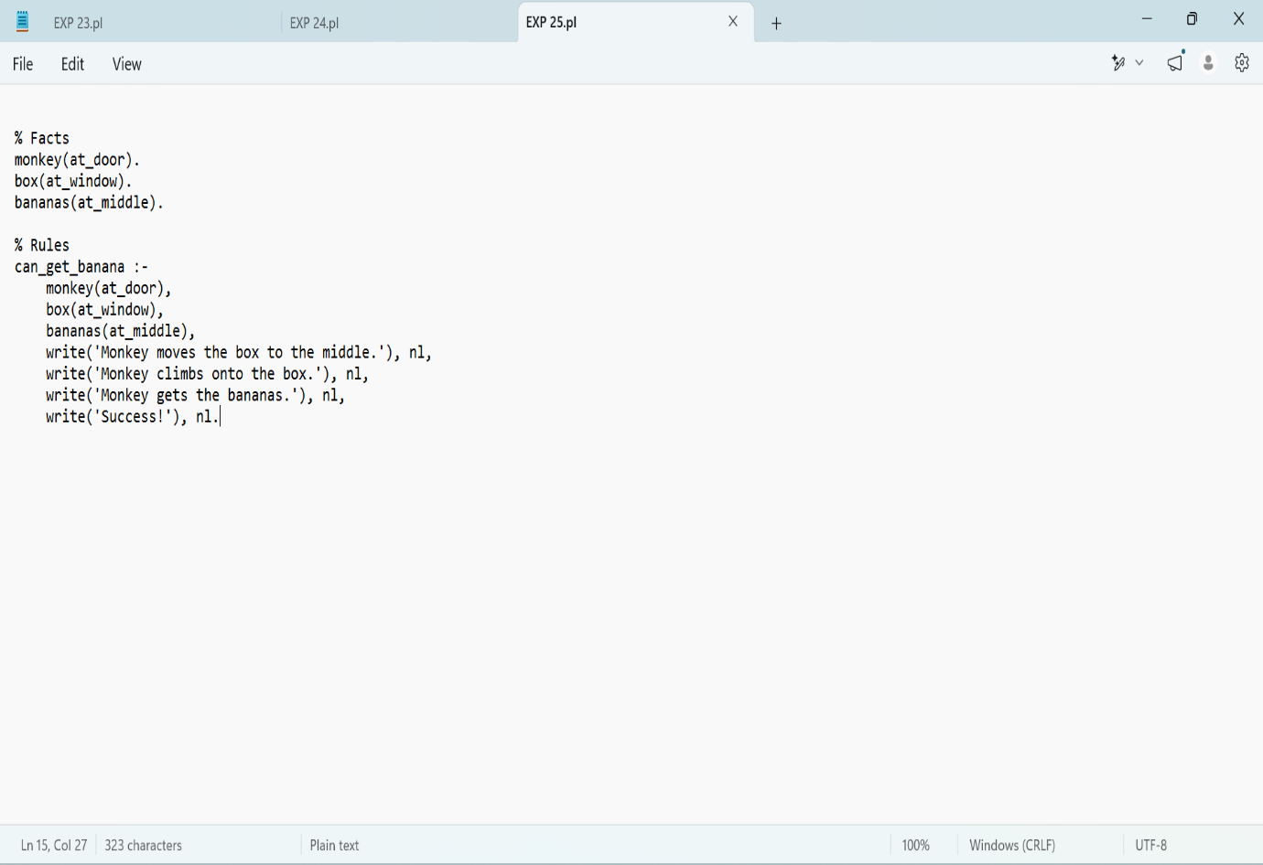

Output
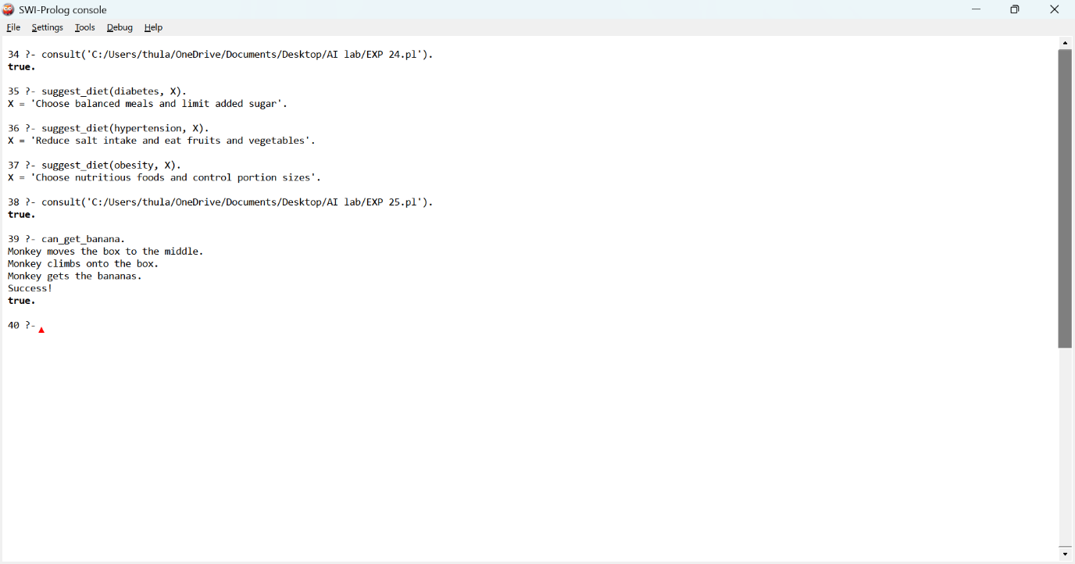

Result
Thus, the Prolog program to implement the Monkey Banana Problem was successfully executed.
Experiment 26: Prolog Program for Fruit and Its Color Using Backtracking
Aim
To write and execute a Prolog program to represent different fruits and their colors and retrieve the fruit details using backtracking.
Algorithm
- Start the program.
- Define facts representing fruits and their colors.
- Create a rule to identify the color of a fruit.
- Execute a query to display the fruit and its color.
- Use backtracking (;) to retrieve the next matching result.
- Display all possible results.
- Stop the program.
Code
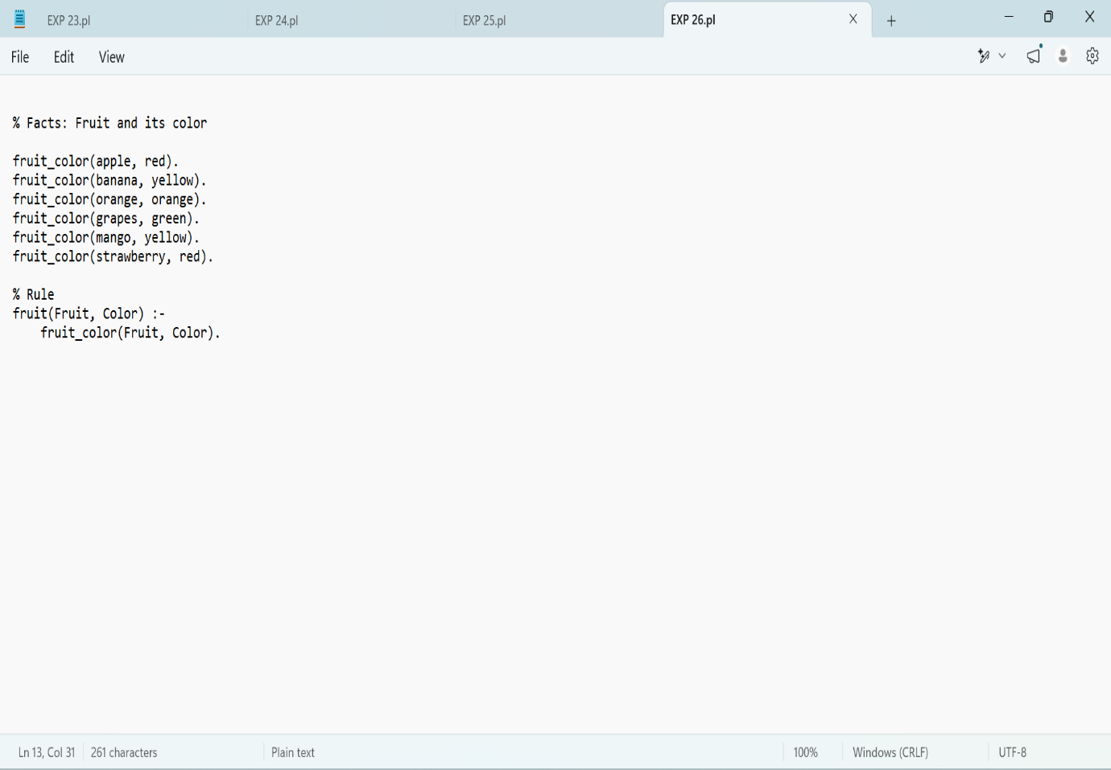

Output
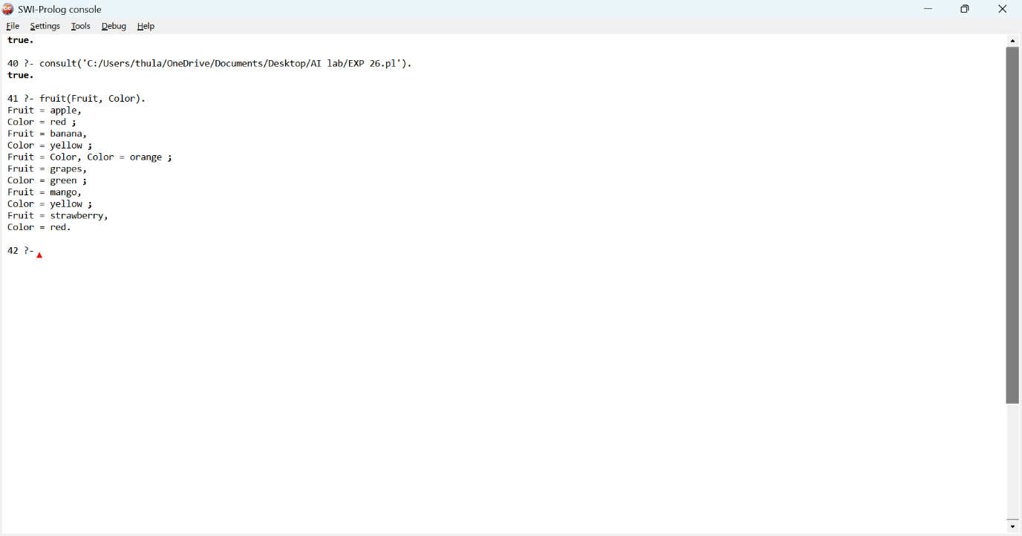

Result
Thus, the Prolog program to represent fruits and their colors using backtracking was successfully executed.
Experiment 27: Prolog Program to Implement Best First Search Algorithm
Aim
To write and execute a Prolog program to implement the Best First Search algorithm to find a path from the initial node to the goal node using heuristic values.
Algorithm
- Start the program.
- Define the graph with nodes and their connections.
- Assign heuristic values to each node.
- Select the node with the lowest heuristic value.
- Check whether the selected node is the goal node.
- If it is not the goal, expand its neighboring nodes.
- Repeat the process until the goal node is reached.
- Display the path and stop the program.
Code
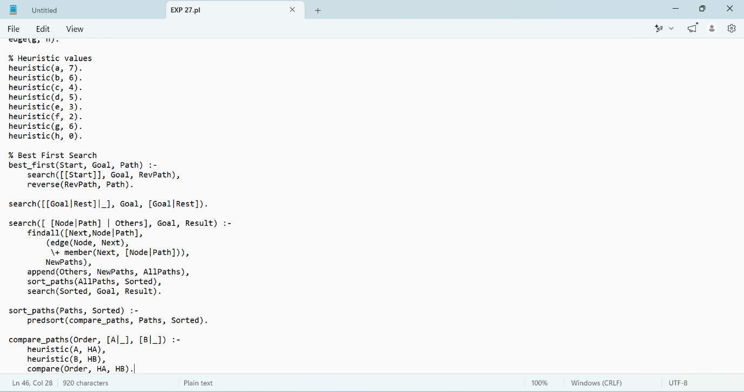

Output
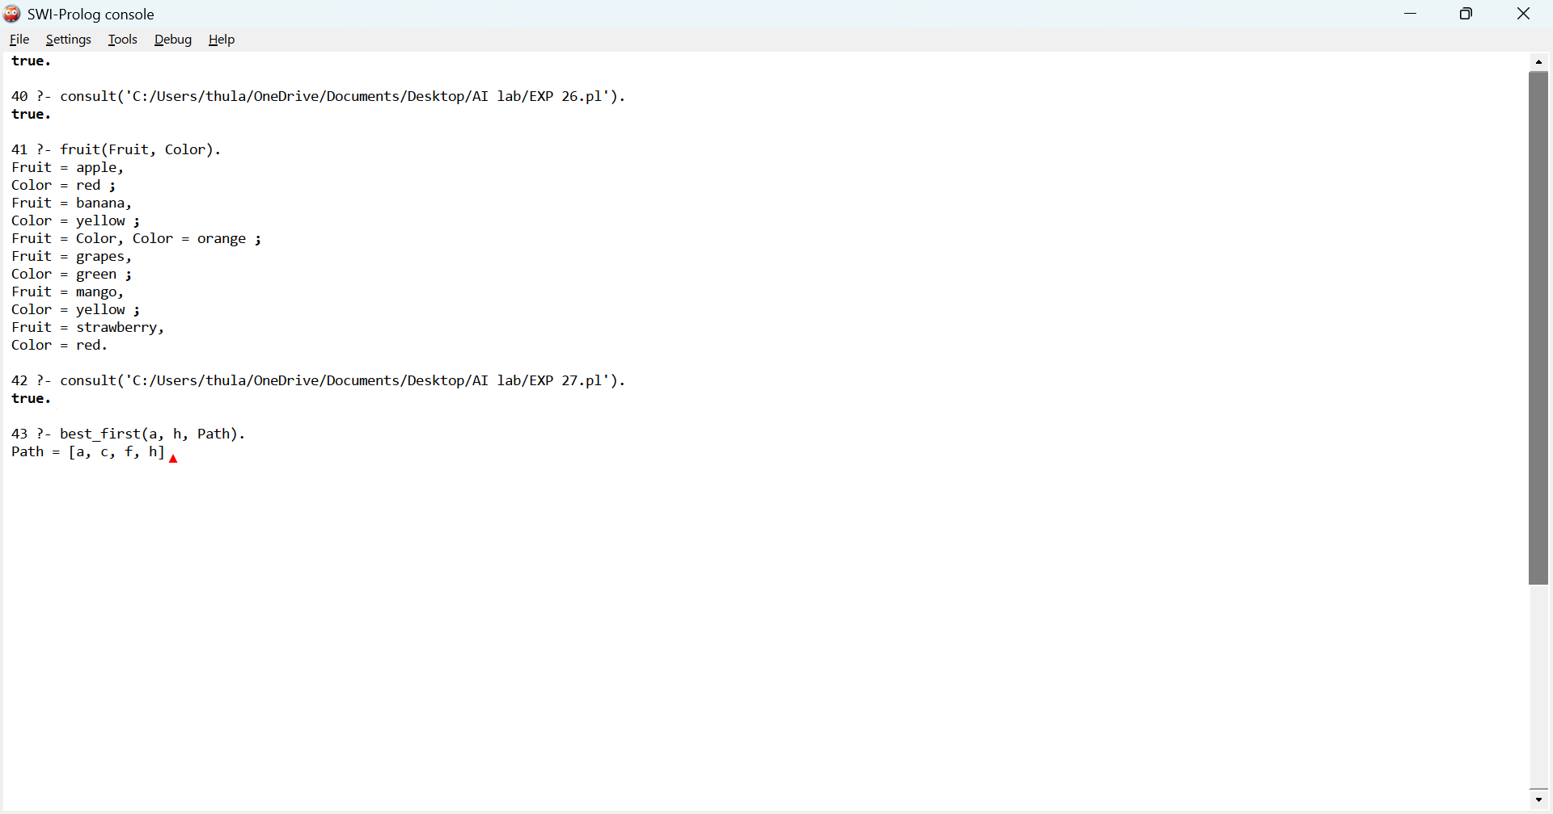

Result
Thus, the Prolog program to implement the Best First Search algorithm was successfully executed, and the path from the initial node to the goal node was obtained.
Experiment 28: Prolog Program for Medical Diagnosis
Aim
To write and execute a Prolog program to identify possible diseases based on the symptoms provided by a patient using logical rules.
Algorithm
- Start the program.
- Define facts for different diseases and their symptoms.
- Create rules to identify diseases based on symptoms.
- Accept symptoms through a query.
- Match the symptoms with the defined disease rules.
- Display the possible diagnosis.
- Stop the program.
Code

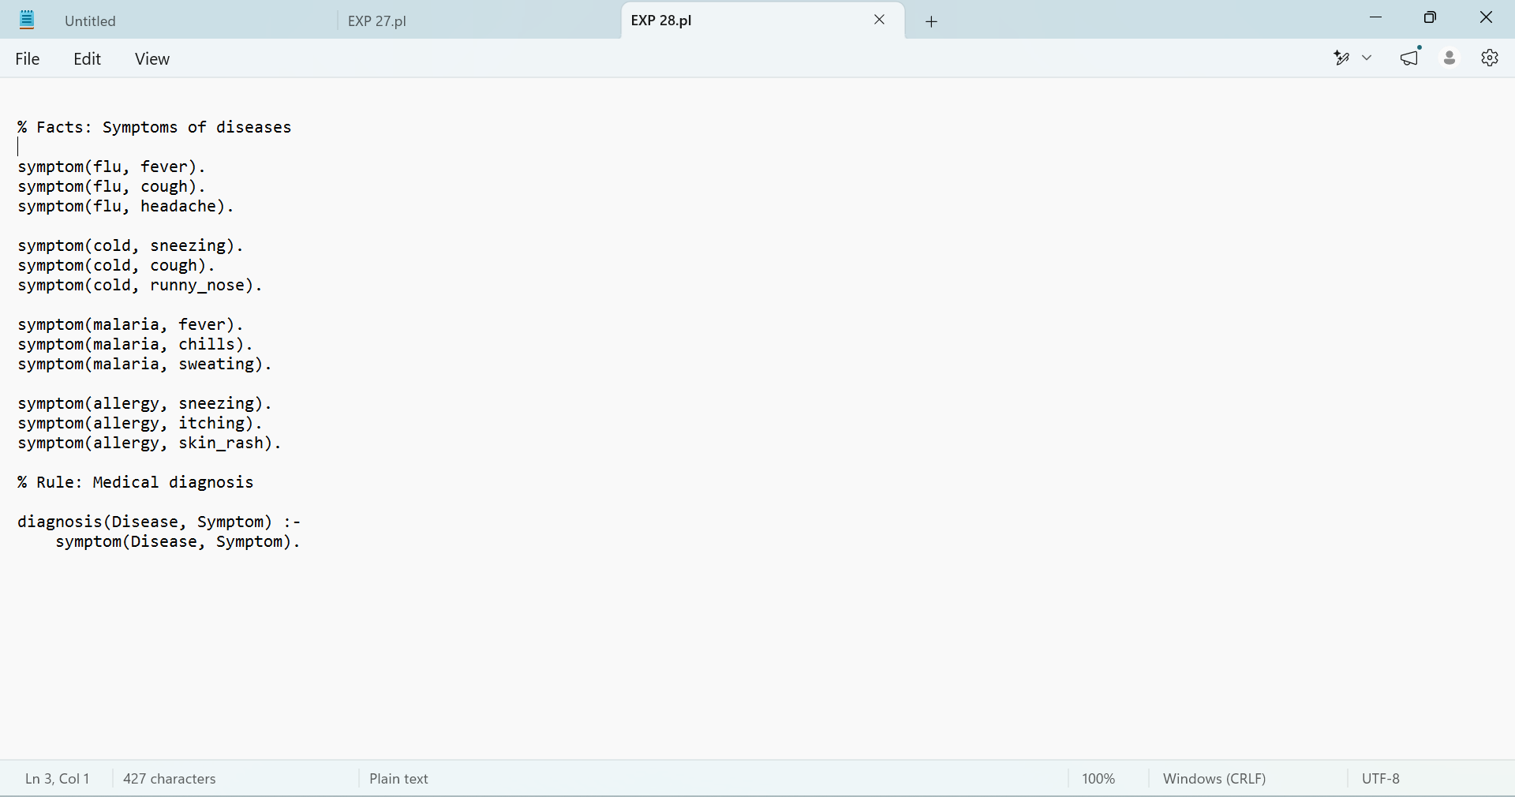

Output
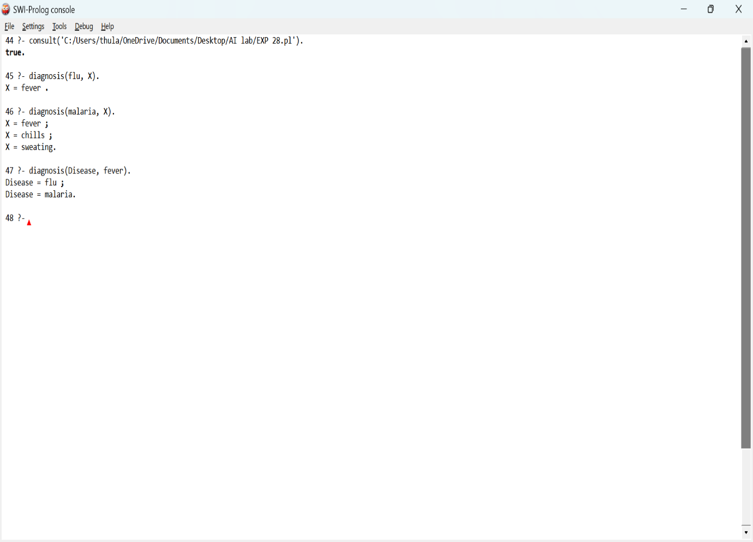

Result
Thus, the Prolog program for medical diagnosis based on disease symptoms was successfully executed.
Experiment 29: Prolog Program for Forward Chaining
Aim
To write and execute a Prolog program to implement Forward Chaining using facts and rules to derive new conclusions from existing knowledge.
Algorithm
- Start the program.
- Define the initial facts.
- Define rules based on the given facts.
- Check whether the conditions of the rules are satisfied.
- Derive new facts using the rules.
- Repeat the process until no new facts can be derived.
- Display the final conclusions.
- Stop the program.
Code
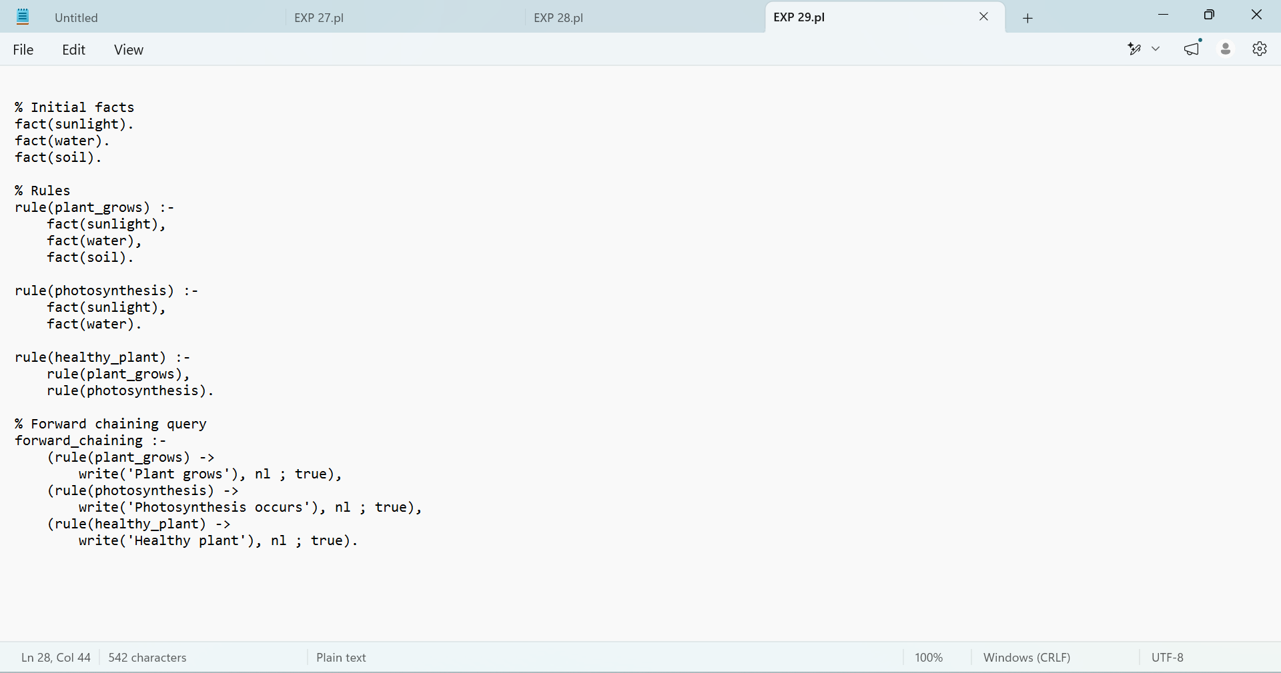

Output
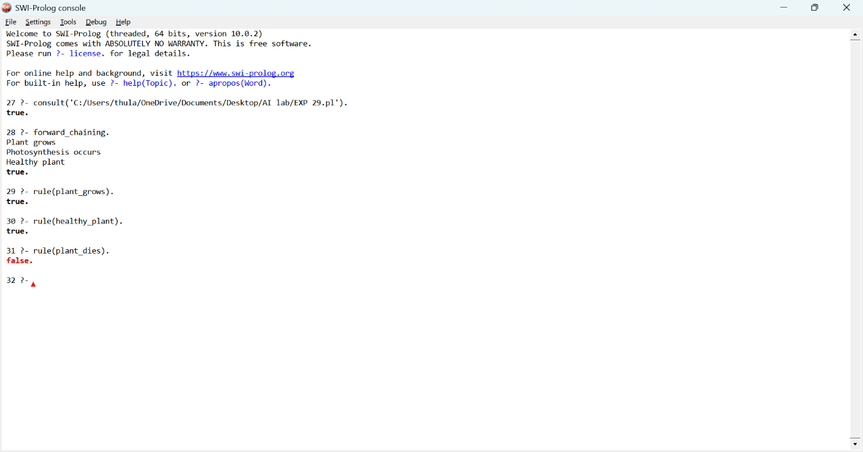

Result:
Thus, the Prolog program for forward chaining was successfully implemented and executed. The required queries were tested, and the system correctly inferred Plant grows, Photosynthesis occurs, and Healthy plant from the given facts and rules.

EXP: 30 Write a Prolog Program for backward Chaining. Incorporate required queries.

Aim
To write and execute a Prolog program to demonstrate backward chaining using facts, rules, and queries.
Algorithm
- Start.
- Define facts such as sunlight, water, and soil.
- Define rules for plant growth, photosynthesis, and a healthy plant.
- Use a goal to start backward chaining.
- Prolog checks the goal and its subgoals against the facts and rules.
- Display true if the goal is proven; otherwise, display false.
- Stop.
Code
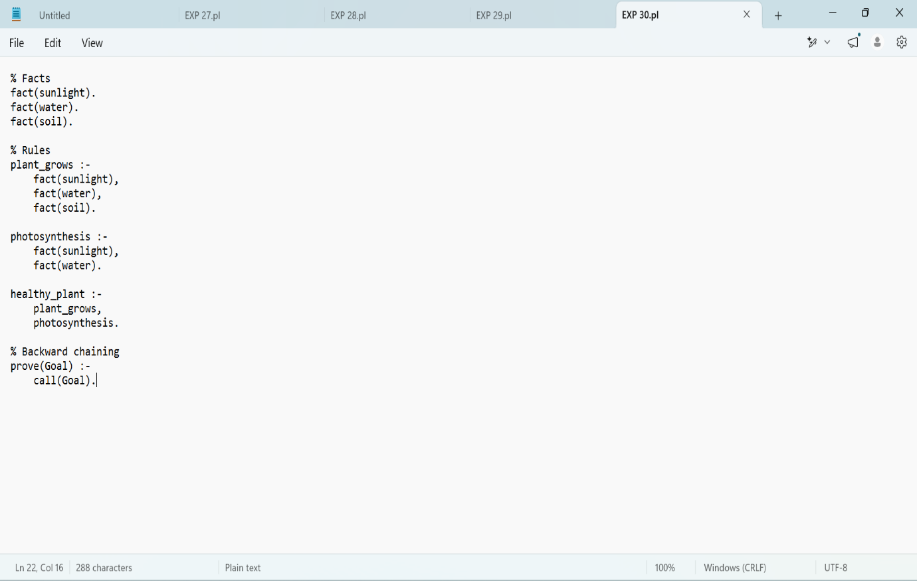

Output
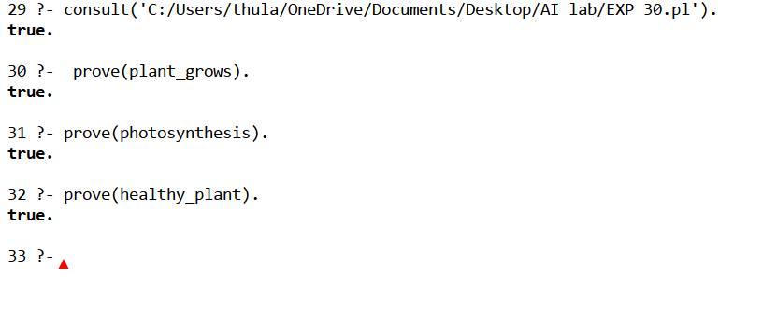

Result:
Thus, the Prolog program for backward chaining was successfully implemented and executed. The required queries were tested, and Prolog correctly proved the goals using the given facts and rules.

